Charger "Li +" for lithium batteries
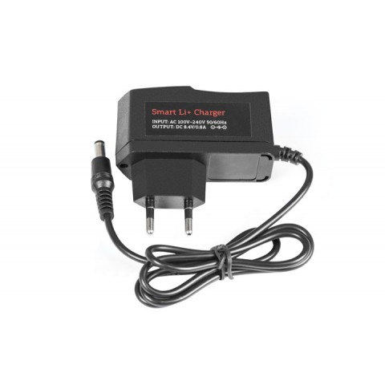

A charger for Li+ lithium accumulators
ATTENTION! Follow the rules of fire and electrical safety. Do not leave the charger unattended!
Model Li+
Voltage 8.4 V
Current 1 A
Capacity 0.75-3 Ah
Power 10 W

